BEE’S HOW TO
**IT IS REQUIRED TO HAVE AN ACTIVE LIQUOR LICENSE AND MUST BE OVER THE AGE OF 21 TO ORDER!!**
STEP 1:
Download app, create account, and fill in all of your account information.

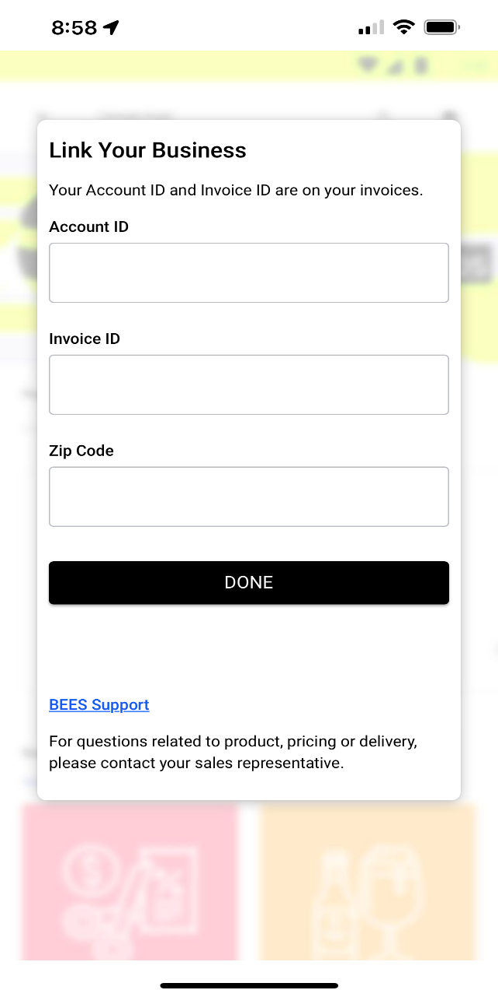

STEP 2:
BEE’S will show you products that you have recently ordered in the “regulars” section.
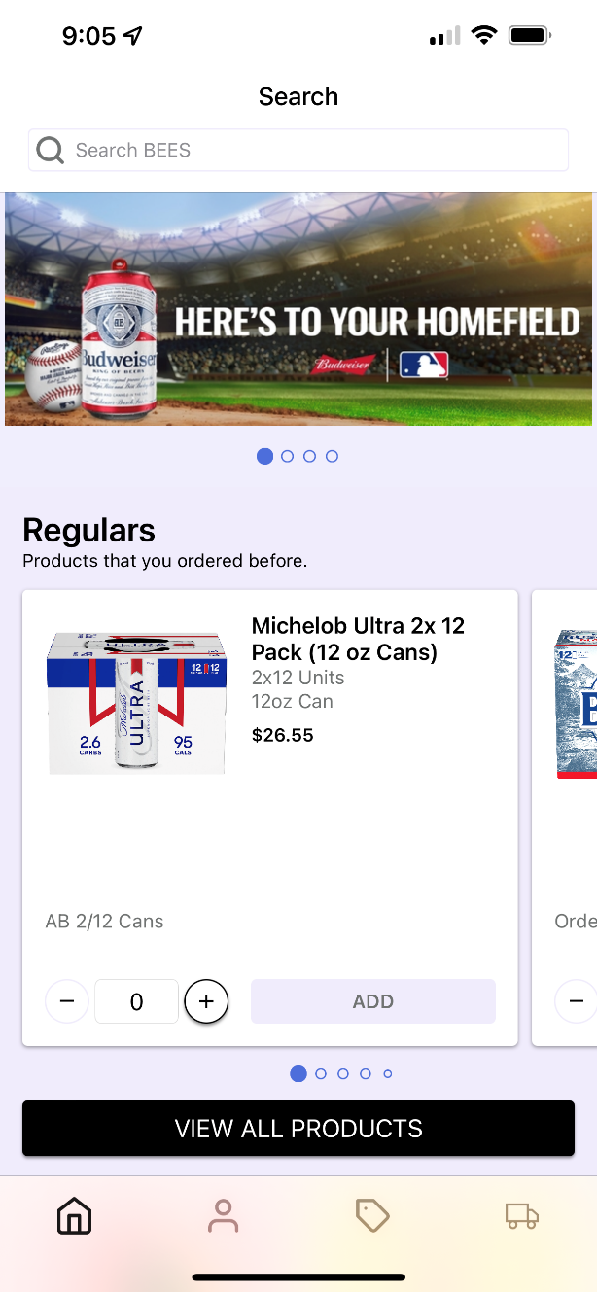

STEP 3:
Scroll through “Regulars” to choose the items and quantities. As you are browsing, you can add quantities to truck
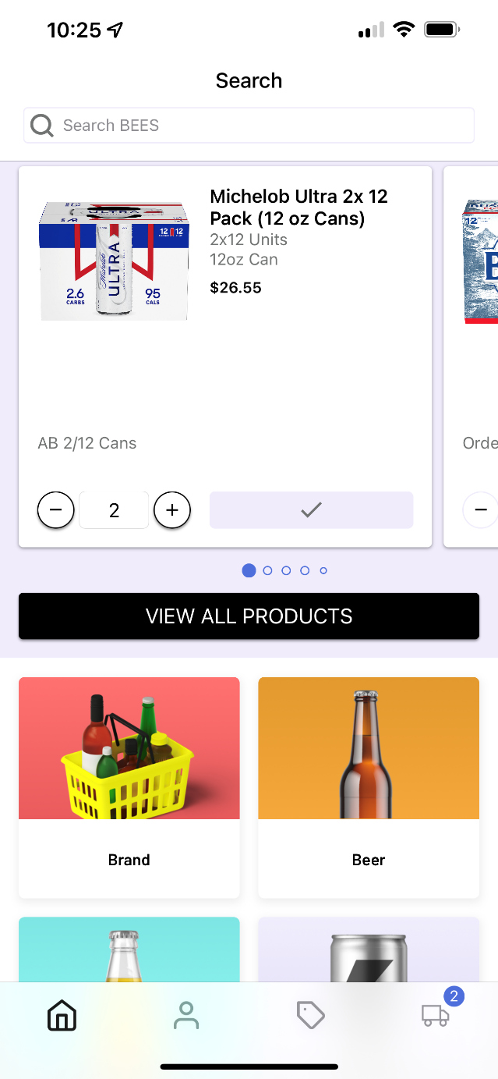

STEP 4:
If you cannot find what item you are looking for, utilize the search engine, use the category navigation tiles.
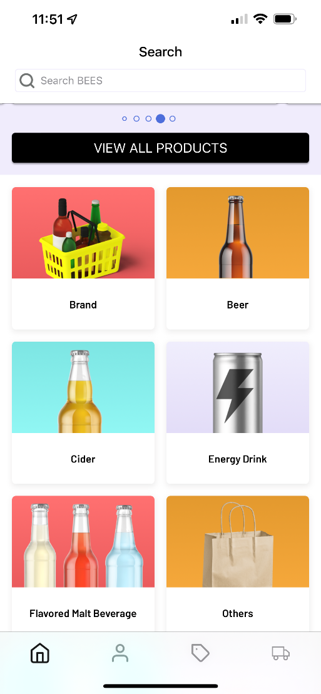
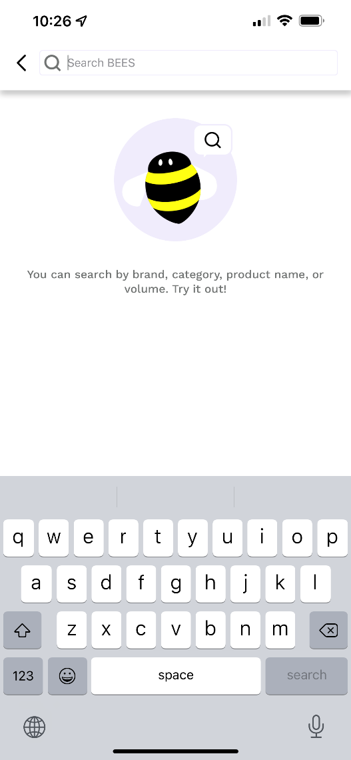

STEP 5:
When you’re done with your order, select the “my delivery” truck icon, in the bottom right corner to view your delivery.
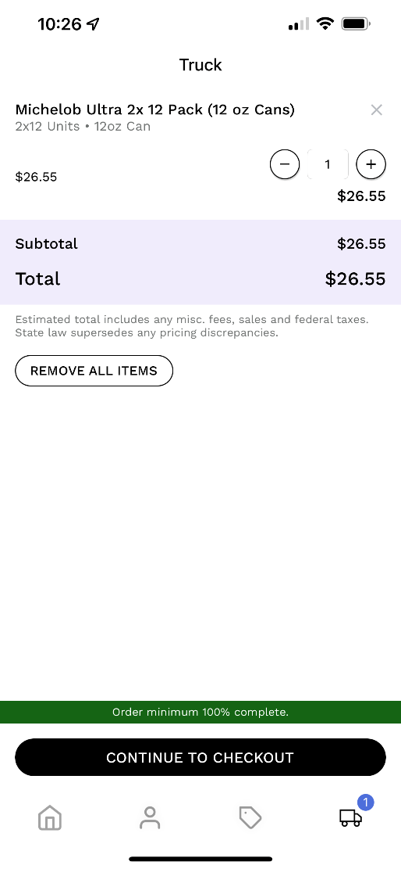

STEP 6:
Confirm that your order looks correct. Discount prices will be highlighted Green.
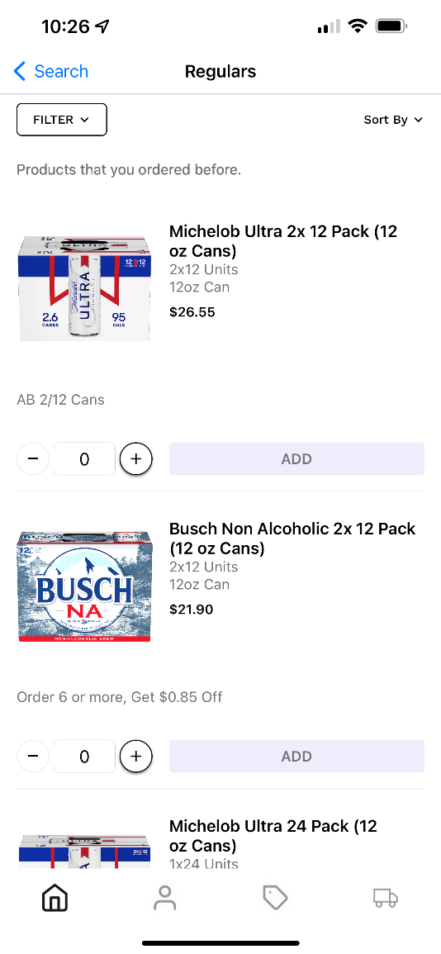

STEP 7:
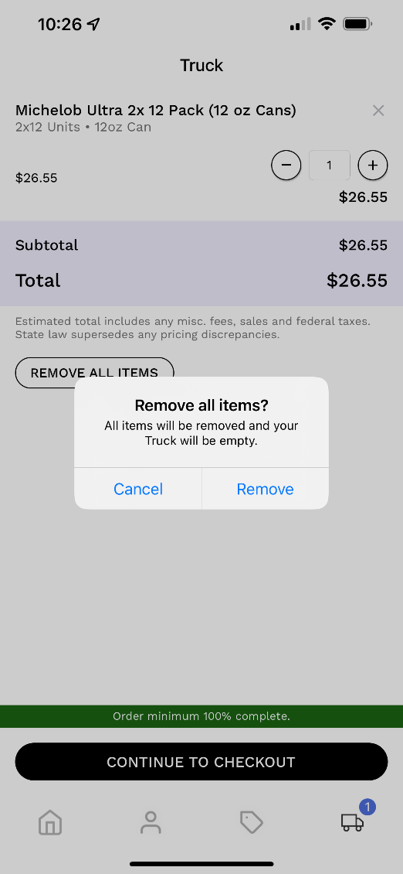
If you want to remove items from your cart, select “remove all items” If you only want to remove ONE item, change the quantity to ZERO on the right-hand side.

STEP 8:
When completed, select a delivery date at the bottom of the page.
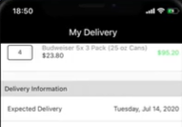

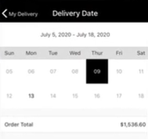
Then confirm your delivery date from the calendar. Dates in BLACK are your available delivery dates. *Dates that are grayed are unavailable*

Then click “SUBMIT ORDER” at the bottom the screen. Once you do that you will receive an email confirmation, stating your order has been received.

